COMPOST

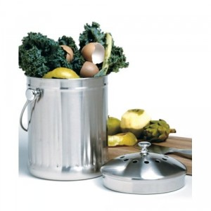
Food Scraps
Organics
Soiled Paper
REFUND

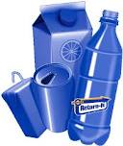
Bottles
Cans
Drink Boxes

RECYCLE

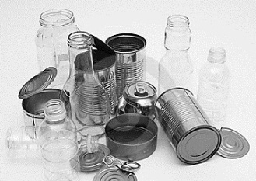
Glass
Metal
Plastic
RECYCLE

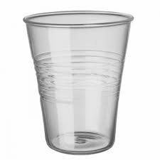
Plastic Cup

PAPER

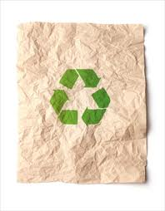
Clean Paper
Magazine
Newspaper

LANDFILL
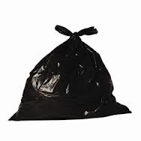

Coffee Cup
Candy Wrapper
Plastic Wrap

